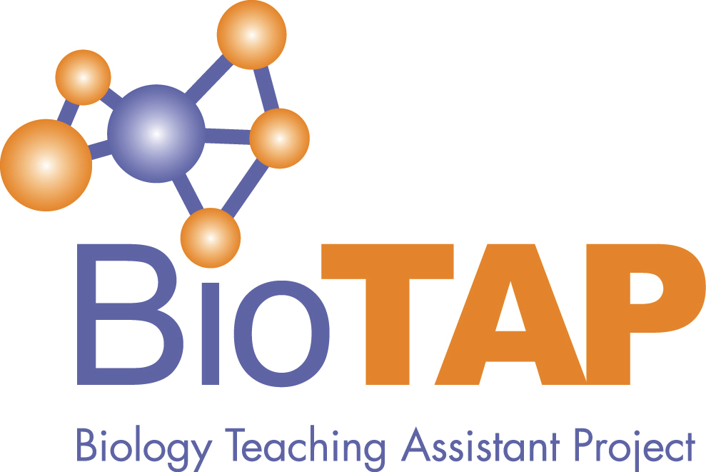
Biology Teaching Assistant Project
2020 Virtual Conference
Monday, October 26, Noon – 4:15 PM EST

Open to all interested in Graduate Teaching Assistant Professional Development for Teaching!

Noon – 12:20 EST Introduction to the Conference and BioTAP
Talk Abstracts

12:20 – 1:10 EST Conference Keynote

Networking for Change: Improving Teaching Professional Development
Through Connections, Collaboration, and Community
Lindsay Wheeler (University of Virginia)

Abstract: Instructors who teach and/or manage undergraduate laboratory courses have no small task when it comes to creating an effective learning environment for students. Not only do instructors create a lab curriculum that enables students to have authentic, inquiry-based experiences, they support the TAs who implement the curriculum. Yet, for many, this is uncharted territory as they were not taught how to teach or how to design and implement professional development (PD). So how do instructors manage adding in research on top of these already monumental tasks? Through the use of story and scholarship, Lindsay Wheeler will discuss her process for and benefits of integrating research, teaching and TA PD. She will also share practical tips for designing and implementing TA PD from the literature and overview areas where further laboratory and TA research is needed.

1:10 – 1:20 EST
On the Evolution of Biology GTA Training: Population Growth and Program Development, Stephanie Gutzler and Matthew Nusnbaum (Georgia State University)

Abstract: In the past 15 years, the number of undergraduate Biology majors at Georgia State University has nearly doubled from almost 1300 to over 2400 students. Historically, 100% of the laboratory courses at the introductory level and more than 90% of the lab courses at the intermediate level have been taught by graduate teaching assistants (GTAs). This explosive growth combined with the reliance on increasing numbers of graduate students to independently manage these courses has led to the development of formalized GTA teaching professional development (GTA-TPD). In 2005, GTA training was a one-day workshop offered in the Fall of each year. Over the past decade, GTA-TPD at our institution expanded from workshops on metacognition, presentation skills, and career advisement into a formal pedagogy course. We aim to share the evolution of GTA-TPD offered at our institution as the culture has shifted over the years from a view of GTAs as facilitators of common course content and grading assistance to future faculty in training, capable of mentoring undergraduate students, creating original materials and implementing pedagogical methods. We will discuss administrative and time-commitment-based hurdles that we have overcome as well as how to generate buy-in among faculty and GTAs.

1:20 – 1:30 EST
Describing the Lack of Effective Professional Development in Biology GTAs. An Exploratory Study. Santiago Ojeda Ramirez, Stephanie Toro, Catalina Arias Zuluaga (Universidad de los Andes)

Abstract: The effectiveness of professional development (PD) for graduate students implementing inquiry-based laboratories has been shown to increase when characteristics like practical details, mentoring, feedback and reflection, pedagogy, modeling and teaching culture are included. In this study we aim to describe the current state of a cell biology course GTA training, evaluate its coherency with these characteristics and to determine current GTAs’ pedagogical content knowledge (PCK), self-efficacy (SE), beliefs about teaching and teaching behaviors. Participants were the 10 GTAs of the Cellular Biology Laboratory course. The current state of professional development scenarios was built through semi-structured interviews that were held virtually and individually. PCK, SE and Beliefs were determined using a survey that included questions from PCK PRIME and Wheeler et al. on beliefs about teaching. Behaviors were coded by two different observers, using the Laboratory Observation Protocol for Undergraduate STEM (LOPUS) on class videos. Data analysis included a reviewed comparative table between characteristics of effective GTA training and training scenarios mentioned in interviews. Pearson correlation was used to test for relationships between SE, PCK and Beliefs. The average percentage of different teaching behaviors on class videos were estimated and then graphed. We found little alignment with effective PD, a significant correlation between PCK and beliefs, as well as high SE. Proportion of behaviors showed GTAs rarely initiate interactions with students, as they mainly employed traditional teaching practices. This study adds to previous research by describing GTAs’ teaching and perceptions given the lack of formal, sustained and effective GTAs training.
1:30 – 1:45 EST
BREAK (get a snack, walk around, come back!)

1:45 – 2:05 EST
Curriculum-linked Professional Development and Higher Cognitive Demand of Curricular Tasks Elevate Teaching Assistants’ Teaching Practices, Jessica Dewey, Jenna Hicks, Michael Abebe, Maxwell Kramer, Anita Schuchardt (University of Minnesota)

Abstract: Teaching assistants (TAs) often lead courses using curricula they did not design. Therefore, examining how curriculum and professional development (PD) interact to influence TAs’ teaching practices is critical. This study describes the effects of an intervention consisting of five short curricular tasks and 4 hours of PD for TAs. TAs teaching ‘Intervention’ sections taught the intervention curricular tasks in addition to the regular laboratory exercises, and participated in Intervention PD that was situated in the context of these specific curriculum activities and modeled the teaching practices TAs were intended to use. Intervention curriculum featured structured opportunities for reform-oriented teaching practices. TAs in ‘Traditional’ (non-Intervention) sections taught the regular laboratory exercises and participated in time-matched PD. The effects of the intervention are assessed in two contexts: when TAs are teaching curriculum that is explicitly linked to PD, and when teaching curriculum that is not linked to PD. TAs that participated in the intervention (N=21) implemented more student-centered teaching practices than TAs that did not participate in the intervention (N=21), even when teaching curriculum that was not designed to be student-centered and was not linked to PD. Linear models of TAs’ teaching practices incorporating curricular task type, PD type, and task cognitive demand indicate cognitive demand has the largest relationship with teaching practices, followed by PD. These results suggest that curriculum-linked PD can be effective in supporting TAs in implementing student-centered practices, even when teaching curricula that is not linked to PD. Higher-cognitive-demand tasks may support or constrain implementation of student-centered practices.

2:05 – 2:25 EST
Community, Direct Feedback, and Cheerleading: Three Practices Identified by Graduate Trainees as Especially Useful in Taking Up Inclusive Teaching Methods, Ben Wiggins (University of Washington), Becca Price (UW-Bothell), Shelley Stromholt (University of Washington), Richard Gardner (University of Washington)
Abstract: Our program trains cohorts of advanced PhD students in the best practices of active, equitable instruction. Through a design-based mixed-methods research arm, we present findings elucidated from graduate students (and the undergraduates that they teach) some of the conditions in which these best practices are taken up by grads. Our specific underlying research question was “What aspects of the STEP-UP training program help or do hot help graduate trainees to take up ambitious teaching practices, and under what conditions? The 9-month cohort of 6 graduate trainees was followed with a qualitative research plan. Our combination of interviews, exit tickets, and open-ended survey responses highlighted the following three practices: 1) Group mentoring created an atmosphere for supportive, self-critical change in teaching outlook and practice. Trainees found this especially helpful for learning inclusive methods, and this seems to have been the case because they were able to learn in an environment of trust from the experiences of peers from multiple viewpoints. 2) Direct feedback for graduate trainees from undergraduate students was identified as particularly important for development of confidence and a supportive teaching persona. Trainees indicate that ‘facing the enemy’ prior to their own instruction allowed them a rare opportunity to understand the mindset of their students which proved useful later. 3) Perhaps least surprisingly, trainees repeatedly indicated that an overwhelmingly positive outlook on the part of supervisors was a necessary ingredient. We will present this in the lens of Ericcson’s Deliberate Practice (1993). These findings will help the iterative design for our future cohorts, and we hope they are useful to others trying to maximize the impact of professional development for graduate students in teaching.

2:25 – 2:35 EST
The “See One, Do One, Teach One” Strategy to Prepare TAs in Course-Based Undergraduate Research Experiences: The Design and Testing of RNA Therapeutics to Block COVID-19, Flobater Gawargi and Martin Hicks (Monmouth University)

Abstract: Engaging students in research through course-based undergraduate research experiences (CUREs) has gained a foothold in recent years. The CURE project introduces authentic research to the undergraduate student, adds to the research program of the PI, and advances the research thesis of the TA. Our goal has been to design a CURE built upon the teaching of concepts while imparting the skills and applications of modern techniques to the next generation of scientist. The TA is trained through the “see one, do one, teach one” approach. To begin, the TA shadows experienced student investigators in the research lab, learns techniques and gains experience in the research methodology. The TA is given the opportunity to carry-out procedures, make mistakes, gain insights and learn the research process. To keep the research real, the TA selects a current aspect of their developing thesis project to advance toward the CURE, adding genuine investment by the TA to the success of the CURE. The TA intellectually develops the timeline and implementation of the project with the PI. A realistic week-by-week, step-by-step flow chart is generated by the TA. In the current program, the TA has developed a CURE in which undergrads learn to design and individually clone a unique RNA therapeutic to block the expression of critical proteins of the virus that causes COVID-19. In our current approach, the TA prioritizes grasping concepts, visualizing the protocol and gaining skills. This strategy has resulted in greater student success in experimental outcomes as well as positive student feedback.

2:35 – 2:55 EST
Unraveling the Failure Mindset for Teaching Assistants and Undergraduate Students in Introductory Biology and Chemistry, Deborah A. Lichti (University of Delaware)

Abstract: Students struggle with failure throughout their academic career because they feel that scientists do not fail. This mindset results in students leaving the STEM fields. In laboratory courses, teaching assistants guide the students through the scientific process but students perceive their results as failures based upon past experiences. The study goal was to determine how students and teaching assistants assess perceived failures based on different scenarios. The online survey was administered to students (n= 21) in Fall 2019 and teaching assistants (n= 18) as the semester began in Fall 2019 and Spring 2020. The four scenarios consisted of situations in the teaching or research laboratory, and the GTA’s own research experience in graduate school. The participants responded by determining whether the scenario was a failure and why. TAs were then asked to discuss how they would handle the situation. Overall, I found that TAs felt most situations were not failures but were learning experiences in the classroom, but when it pertained to their own research they had mixed feelings. TAs felt the best plan of action was to have conversations with the students about their results and reassure them that their grades would not be affected. TAs also felt that sharing their own scientific experiences or failure examples would help the students better appreciate science. Students were divided on what was perceived as failure in these scenarios. There is a mismatch between students and TAs on perceived failure and future training programs could help reduce these gaps.

2:55– 3:10 EST
BREAK (get a snack, walk around, come back!)

3:10 – 3:30 EST
Seeing Equity in Education (SEE): First Steps Towards the Development of the SEE Instrument, Gena Sbeglia and Ross H. Nehm (Stony Brook University)

Abstract: Inclusive practices are associated with increased belonging, and decreased race- and gender-based learning disparities. However, educators who do not “see” inequities may be unable to embrace inclusive excellence. We are developing an instrument for measuring the ability to “see” equitable practices in undergraduate classrooms. We compiled a SEE (Seeing Equity in Education) framework that includes 60 practices from the literature, and used it to identify these practices in recordings from a high enrollment introductory biology class. We selected two ~2-min videos targeting framework elements: classroom structure/organization, participation, feedback. The videos were piloted with 33 undergraduate and four graduate TAs. TAs rated interactions in the videos along two continua: helpful vs. unhelpful, alienating vs. inclusive. Most TAs found video 1 alienating (25/37) and unhelpful (22/37). Among the respondents who reported the interaction as neutral/inclusive, nearly all (7/11) also reported it as unhelpful. Therefore, while TAs recognized an unhelpful interaction, they did not necessarily identify alienating practices. After discussing video 1, most (33/35, two TAs did not respond to video 2) indicated that video 2 was alienating. These preliminary results suggest that TAs differ in their ability to “see” inequities. This is a small but important step in the development of the SEE instrument.

3:30 – 3:50 EST
What Do TA Teaching Perspectives Say About Their Views of Teaching and Learning? Joshua Reid (Middle Tennessee State University) and Emily Weigel (Georgia Institute of Technology)

Abstract: There is overwhelming evidence on the effectiveness of evidence-based instructional practices, yet these practices are still largely absent in undergraduate science, technology, engineering, and mathematics (STEM) courses. While a myriad of factors are related to whether these practices are adopted and implemented, teaching perspectives and beliefs about teaching and learning are particularly salient. These perspectives shape teaching practices through the interrelation of beliefs about teaching and learning and actions resulting from these beliefs. In this study, we explored the teaching perspectives of 48 graduate (n = 25) and undergraduate (n=23) TAs as well as shifts in their perspectives after participation in an active learning professional development course. Findings from this study suggest that while undergraduate TAs hold more nurturing perspectives of teaching, graduate TAs hold more apprenticeship perspectives. In other words, undergraduate TAs teaching beliefs tended to focus more on both cognitive and affective outcomes while graduate TAs tended to be more concerned with guiding and challenging students to become independent thinkers and learners. Furthermore, we found differences in teaching perspectives to be based on gender and course context (i.e., lecture-based course or laboratory-based course) rather than solely on their participation in the professional development. We also found evidence that TAs did not hold one perspective but many participants held two dominant perspectives (i.e., transmission and apprenticeship). This suggests that professional development programs should emphasize helping TAs solidify their perspectives rather than change their perspectives.

3:50 – 4:10 EST
Ecological Belonging Interventions Can Eliminate Performance Gaps, But Instructor Mindset Matters, Sarah Hammarlund (University of Minnesota), Cheryl Scott (University of Minnesota), Kevin Binning (University of Pittsburgh), Sehoya Cotner (University of Minnesota)

Abstract: Evidence suggests that students’ sense of belonging predicts performance and retention in higher education. Introductory STEM courses, however, are often taught in large classrooms that do not facilitate belonging, and not all instructors foster a sense of belonging. Discrimination and negative stereotypes can also contribute to an unwelcoming classroom environment. A low sense of belonging often raises doubts about one’s ability to succeed, which are disproportionately shouldered by students from marginalized groups. Recently, “ecological belonging interventions” have shown promise in eliminating performance gaps in STEM courses at the University of Pittsburgh. These brief classroom-based interventions aim to change classroom norms and instill the idea that adversity is normal, temporary and surmountable. An open question is whether the success of belonging interventions depends on instructor characteristics. We will present the results of an experiment at the University of Minnesota designed to identify the contexts in which belonging interventions are effective. Using course performance and survey data, we found that the intervention eliminated a performance gap between racially minoritized students and white and Asian students in a chemistry course. In a biology course, we explored the impact of teaching assistants' mindset on the effectiveness of the intervention. We found that TA beliefs about intelligence, specifically whether TAs adopt a “growth” or “fixed” mindset, moderates the effect of the intervention. Finally, we share ideas for how belonging interventions can affect TA empathy.

4:10 – 4:15 EST Closing

The Biology Teaching Assistant Project (BioTAP) is a research coordination network funded by the National Science Foundation (DBI 1539903) to empower universities to use research to improve the quality of graduate student teaching

