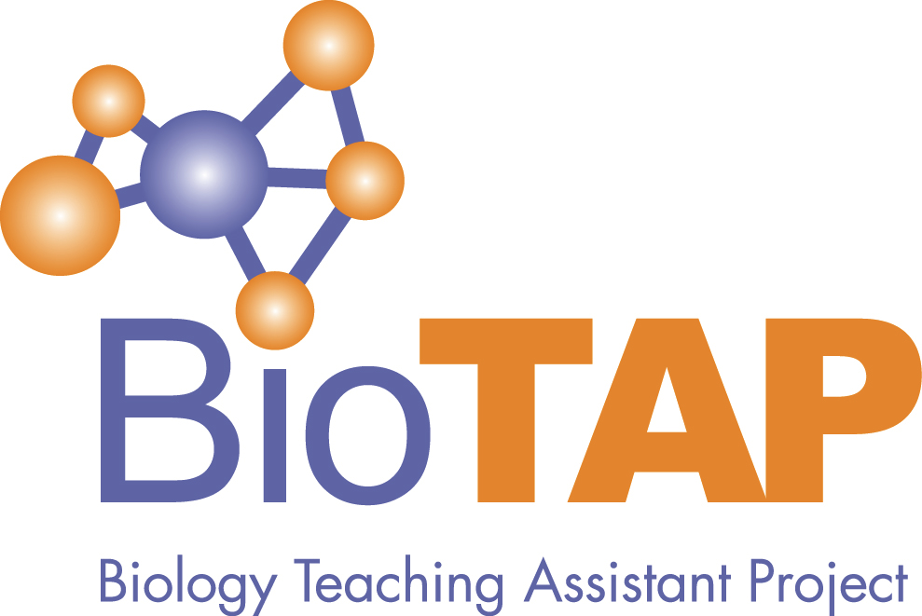

Biology Teaching Assistant Project
News Update

Released Monday, Aug. 21, 2023
Greetings BioTAP,

On the verge of another academic year, the BioTAP leadership wanted to reach out with an update about network activities, as well as some important announcements for the year ahead.

First and foremost, we are pleased to announce that the BioTAP virtual conference will take place this fall over two days: October 30th and 31st, 2023 (on Zoom). We are currently seeking applications for talks of 12 minutes (with three additional minutes for questions), and abstracts will be due by September 15th. Talks should focus on research or evidence-based practices related to providing teaching professional development for teaching assistants (TA-TPD).

The conference is totally free of charge, but we ask that you register for planning purposes. You may register and submit your abstracts here: https://oregonstate.qualtrics.com/jfe/form/SV_af547llrHO3OD8q

As you may also know, the last few years have been a time of transition for BioTAP, as we have successfully shifted from a grant-led effort to an organization that can maintain the network, continue offering the conference, and work towards our ongoing mission to foster research and evidence-based practices for TA-TPD. Growing out of the work of a Governance Task Force at the end of the prior grant’s funding period, we have crafted an organizational structure for the network, written and ratified Bylaws for how we will operate (linked on our website for anyone interested), and appointed officers for this transitional period until we can make it to our first election cycle (see list below). That brings us to our second big announcement.

Following the conference, we will be holding our inaugural fall elections for two key positions: the President Elect and a Treasurer. After this first election season, we will have filled all officer positions, at which point we will consider it “Year One” of the new BioTAP era, and we will move into the regular annual election cycle (outlined in the bylaws). Early in the upcoming conference, we’ll dedicate a session to discuss the BioTAP governance structure and the timing of the elections, which will include a call for nominations and election logistics. In the meantime, if you have any questions about applying for one of these leadership positions, or about BioTAP in general, feel free to reach out to me at any point (adam.chouinard@oregonstate.edu).

Other than that, we are looking forward to your abstracts and excited to bring the network together synchronously for another virtual conference this fall!

On behalf of the Executive Committee,

Adam

BioTAP Executive Committee:
Adam Chouinard, Acting President
Elisabeth Schussler, Past President
Dan Johnson, Networking Committee Chair
Erin Shortlidge, Education Committee Co-chair
Lori Kayes, Education Committee Co-chair
Frank Castelli, Conference Committee Chair

Learn more and get involved at https://biotap.org

